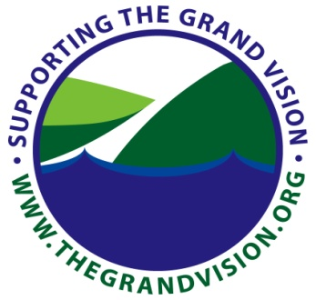
Grand Vision to Grand Action

Outline for HUD Grant Transportation Plan

Roads & Highways
- Local, Federal Aid & Tribal Road delineation
- Corridors of Significance/ statewide / regional / local
- Road Safety Audits
- Air Quality
- Seasonality
- Access Management
- Socio-Economic/Environmental/Social Equity Issues
- Freight
- Maintenance
- Vehicle Mile of Travel (VMT) (measures to reduce)
- Funding/Reauthorizaton
- Rural – Urban transportation connections & regional issues
- Complete Streets
- Coordination with other state/local and regional plans
- Parking
- Accessibility/Social Equity
Non-Motorized
- Identification of transportation trails and recreational trails
- Accessibility/Social Equity
- Funding
- Road crossings
- Pedestrian/Non motorized crossings on state highways
- Pedestrian Safety Audits
- Bicycle Safety Audits
- Seasonality
- Complete Streets
- Coordination with other state/local and regional plans
- Maintenance
- Off Road and On-Road facilities

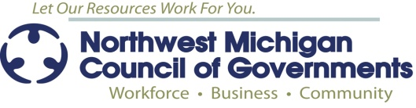

Grand Vision to Grand Action

Outline for HUD Grant Transportation Plan (continued)
Transit
- Bus stop inventory
- Service inventory & transfer points (linkage and connectivity)
- Seasonality
- Potential VMT reduction/Demand Management
- Accessibility / American with Disabilities Act / Social Equity
- Transit Oriented Design principles
- Complete Streets
- Maintenance
- Funding
Rail
- Rail viability and linkages
- Freight analysis (definition?) & assessment
- State Rail Plan & North Region Economic Development study
- Passenger rail potential
- Grade crossing safety
- Maintenance
- Funding
Water
- Active Ports (definition?)
- Freight analysis & assessment
- Ferry Service
- Maintenance
- Funding
Air
- Commercial and General Aviation service & facilities
- Freight (NEXT Michigan)(definition?)
- Seasonality
- Maintenance
- Funding

