Building a smarter and stronger electrical energy infrastructure

By Jim MacInnes
October 11, 2011

This last article of our energy series focuses on the need to upgrade America’s electric power grid.

Fossil fuels are non-renewable, that is they draw on finite resources that are becoming increasingly expensive as they make their way toward eventual depletion. In contrast, renewable energy sources such as wind, solar, ocean, biomass, hydro, etc. can be replenished at a generally predicable rate. To accommodate our necessary transition toward higher penetration levels of these types of variable generation, the electric power grid must be transformed.

Building a smarter and stronger electrical energy infrastructure requires advancement in three areas: 1) transforming the network into a “smart grid,” 2) expanding the transmission system and, 3) developing large-scale electricity storage systems. This is the fourth recommendation by the IEEE-USA national energy policy committee.

Adding intelligence such as sensors, advanced communications and coordinated control systems, and computers to our electrical grid infrastructure can substantially improve efficiency and reliability through enhanced situational awareness, reduced outages, and improved response to disturbances. It also enables flexible electricity pricing that will allow consumers to monitor and control their own energy usage and costs.

Much of the renewable generation potential is located in areas remote from population centers and which are not connected to our bulk power transmission infrastructure. We must invest in additional transmission capacity to link these renewable generating sources with homes and businesses as well as to facilitate our transition from oil-based…. to electricity-based transportation.

Generation supply variability is reduced through aggregation and diversity. Interconnecting a large and geographically dispersed number of intermittent generating sources creates large ‘energy-balancing’ areas. These energy-balancing areas smooth out power supply variability the same way a dispersed portfolio of stocks and bonds smoothes out investment returns. (See graphic below) This can be a very effective way to increase the penetration of renewable energy into the grid while also reducing fossil fuel consumption and greenhouse gases. Germany, for example, has achieved over 20% penetration of renewables and plans to achieve 35% to 40% renewable energy penetration by 2020.

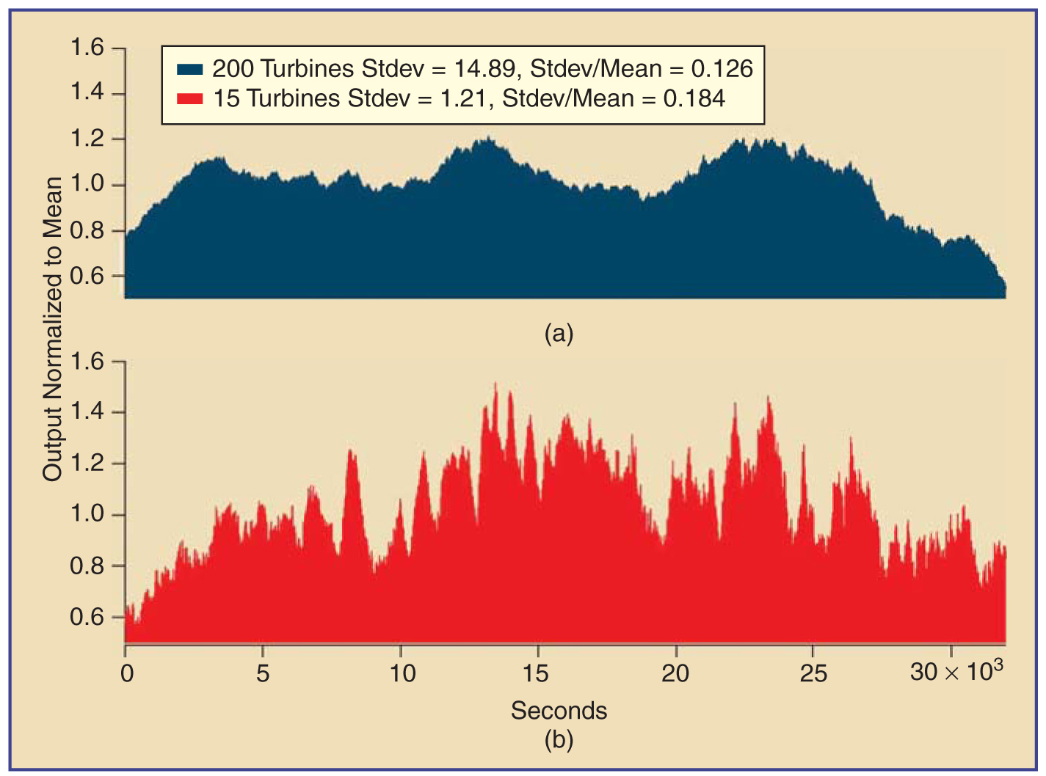
Comparison of second-to-second variability of wind production between (a) wind plant with 200 wind turbines and (b) a wind plant with 15 turbines. Based on data from the National Renewable Energy Laboratory (NREL).
Unlike many other types of energy resources, electricity is generated and consumed instantly. If intermittent generating resources are to reach their full potential in contributing to our nation’s power supply requirements we must also incorporate large scale energy storage. This will allow renewable energy to be transformed into other forms of energy, stored and then later converted back to electricity when needed. This storage system can act as a load leveler, to facilitate more efficient grid utilization, and it can be used in responding to system disturbances. Michigan’s Ludington pumped storage facility is a prime example of this type of asset.

As Battery Electric Vehicles (BEV’s) become a significant part of our transportation system they may also be utilized for energy storage. Used EV batteries are expected to have over 80% of their useful life remaining even though they may no longer be suited for transportation purposes. These recycled batteries may be aggregated in nodes located throughout the grid and used to help supply some of this energy storage. In the future, it may even be possible to supply energy from parked BEV’s that are plugged-in to smart charging stations.

Jim MacInnes worked as a power engineer for the company that designed and construction managed the Ludington Pumped Storage facility, in addition to coal-fired and nuclear power plants. He is a licensed professional engineer in Michigan, a member of the IEEE Power and Energy Society and the International Society for Ecological Economics. He served on the Great Lakes Offshore Wind Council and was named as a Michigan Green Leader by the Detroit Free Press. He holds BSEE and MBA degrees from the University of California.

