January 6, 2012

Dear Elected and Appointed Officials:

As a result of your suggestions to give more attention to transportation planning in northwest lower Michigan and re-organization efforts currently underway at the Michigan Department of Transportation (MDOT), the Northwest Michigan Council of Governments (NWMCOG) has been asked to assist MDOT in their transportation planning and outreach efforts. As such, we will be coordinating and providing an opportunity for local elected officials and the general public to comment on the State Transportation Improvement Program (STIP). The STIP acts as the process to guide many of the future transportation improvements in the region. For more information on the transportation planning process, see: http://www.nwm.org/citizensguide.asp

The NWMCOG and MDOT requests your participation at this meeting (agenda attached), as we will be meeting to consider the inclusion of regional transportation projects into MDOT’s 5 year plan. It is important that we have input from our local elected officials to ensure this plan meets local needs.

You are invited to attend a regional transportation planning meeting at The Kaliseum in Kalkaska (see map attached) on Tuesday, February 7th, at 2:00pm.

I look forward to working with you on the development of a viable rural transportation planning process in northwest lower Michigan! In order to accurately gauge attendance, please RSVP to my email address michaelwoods@nwm.cog.mi.us or office number, 231-929-5056. Thanks.

Sincerely,

Michael P. Woods, AICP
NWMCOG Regional Planner

NWMCOG/MDOT Public Participation Process – 2012

Agenda

- Introductions

- Overview of Program by NWMCOG Personnel

  - New Process

  - Explanation and purpose of FHWA’s Rural Elected Officials meetings

  - Changes in the Rural Task Force program

- Comments from MDOT on funding at the national and statewide levels

- MDOT presentation on:

  - Statewide and Regional Strategies

  - MDOT’s current Five Year Plan

  - North Region project selection process

- MDOT Transportation Service Center (TSC) presentation on 2017 projects

  - TSC Staff will review projects being considered for inclusion in the Five Year Plan for proposed 2017

- Public Comments and Questions

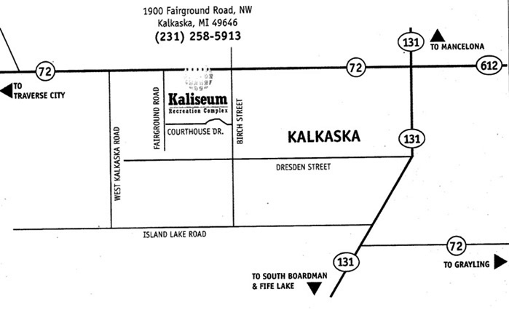
Map

